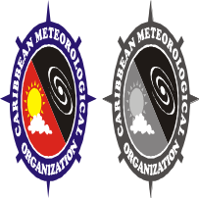
C A R I B B E A N
M E T E O R O L O G I C A L
O R G A N I Z A T I O N

CARIBBEAN METEOROLOGICAL COUNCIL Doc. 9
FIFTY-FIRST SESSION
Roseau, DOMINICA, 17-18 NOVEMBER 2011

CMO WEATHER RADAR NETWORK/PROJECTS
(Submitted by the Coordinating Director)

Introduction

1. The 13.2 million Euro CARIFORUM-administered, European Union-funded CMO Weather Radar Project came to an end in 2009. The Project, implemented by the CMO Headquarters, installed four powerful German-made S-band Doppler weather radars in Belize, Barbados, Trinidad and Tobago and Guyana to form a network that replaced the old and obsolete CMO radar network that served the region for over three decades from the late 1960s. The new network, along with other pre-existing radars in other Caribbean islands, provides the Caribbean with a modern sophisticated tool that complements other surface- and satellite-based weather observing platforms as part of the regional early weather warning system. There are still some weak points...or holes...in the regional radar coverage. There are also technical issues that need to be ironed out before one can say that the overall system works perfectly. This document will examine the operational status of the CMO radar network and other systems, as well as measures to fill one major gap in the Western Caribbean through a similar radar project in the Cayman Islands.

(a). STATUS OF CMO RADAR NETWORK OPERATIONS

Operational Status:
- The images in Figure 1 indicate that the four new radars are currently functioning. For the most part, operations are close to normal in most locations. The radars have all made an immense impact on the forecasts and warnings issued by the Meteorological and Hydrometeorological Services for their territories and areas of responsibilities, as well as neighbouring Member States. The Belize radar has worked through several tropical storms and hurricanes since its installation, including several in 2011, while the others have captured multiple episodes of severe weather that have led to flooding and damage to property. Data from all the radars are archived in electronic form for easy retrieval for studies of various types. The importance of this was demonstrated in Guyana when all radar data was easily retrieved to assist in the investigation of an aircraft landing mishap in July 2011.

Website Access and Usability:
- All four Meteorological Services operate Websites that provide access to the radar imagery, as follows:
Belize: http://www.hydromet.gov.bz/
Barbados: http://www.barbadosweather.org/
Trinidad: http://www.metoffice.gov.tt/
Guyana: http://www.hydromet.gov.gy/

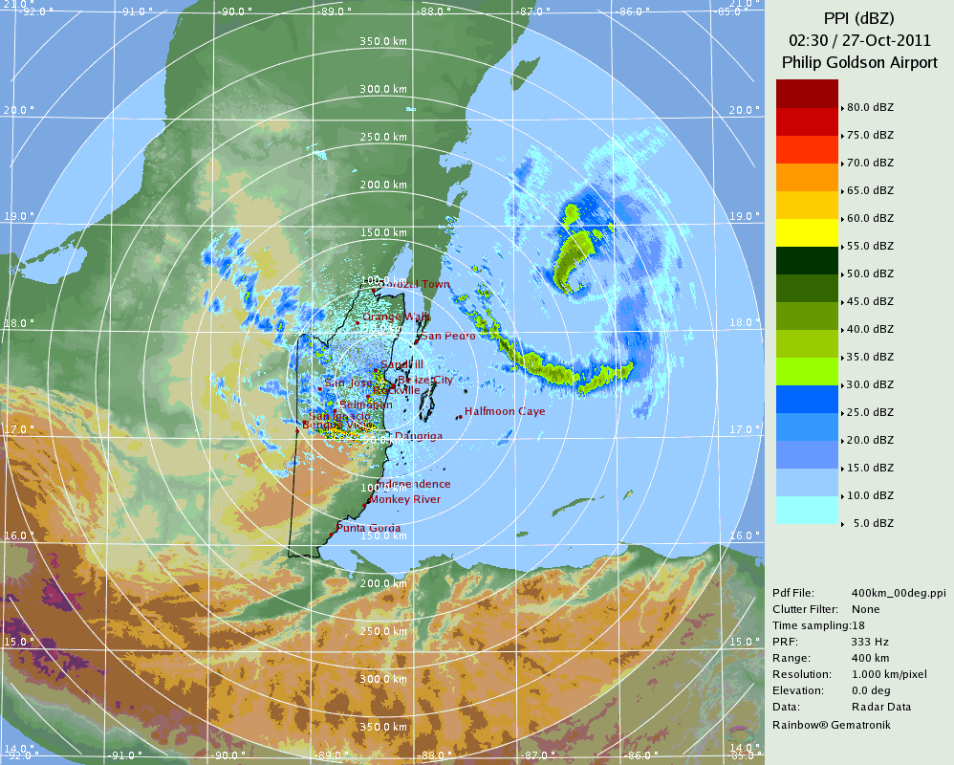
Figure 1(a): Belize radar – 400km (Hurricane Rina)

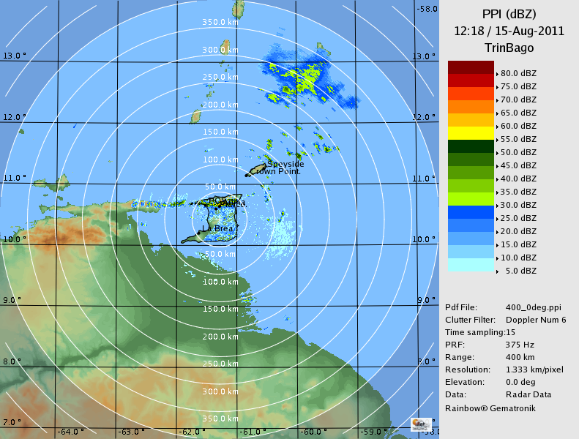
Figure 1(c): Trinidad radar – 400km

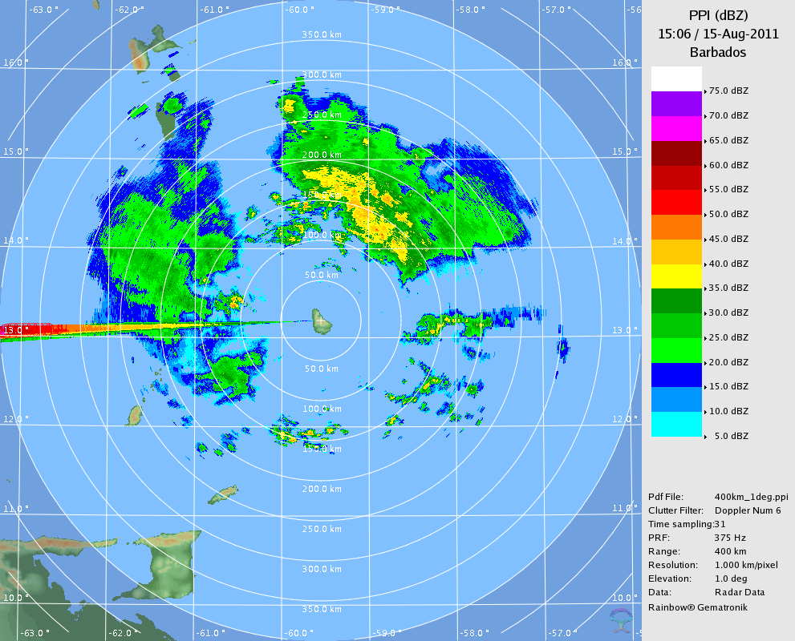
Figure 1(b): Barbados radar – 400km

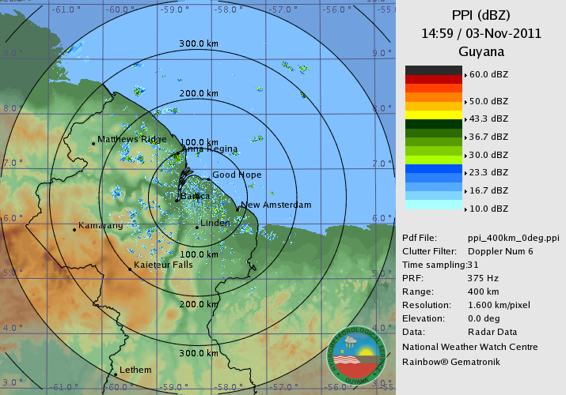
Figure 1(d): Guyana radar – 400km

3. The range of products used by the Meteorological Services that operate the radars and the variety of products offered to the public and other users vary somewhat from site to site. All four sites offer images in various ranges downwards from the maximum 400km, depending on location. For example, Belize, Barbados and Guyana offer 50 km as the lowest range, while the lowest range offered from the Trinidad radar is 150 km to encompass both islands - Trinidad and Tobago. The usefulness of the Websites, however, depends on several factors, such as (i) publicity; (ii) user-friendliness; (iii) type of products offered; (iv) looping facility and (v) frequency of updates (automated). If the existence of a Website is not known to the public, natural disaster/emergency organizations, the media and other users, the usefulness outside of the meteorological community would be limited. General observation by CMO staff is that the radar images are not utilized by the media in all locations or in neighbouring States that are also within the range of a particular radar. In one case, there is the need for the user to install “non-standard” software in order to access the radar imagery, which may not always be accepted by Internet users; thus it is much more practical to use software that is considered to be standard.

4. In this regard, it is strongly advised that each Meteorological Service operating the radars publicize the existence of their Websites in general and the availability of the radar images in particular through the local print media. It is also advisable that Meteorological Services in neighbouring States that are covered by one or more radar, publicize those sites and give access to those sites through their own Websites. Specifically, it would be practical for St. Vincent & the Grenadines and Dominica to provide a link on their Websites to the Barbados radar images and other forecasts/warnings for their territories. Grenada can do the same with both the Trinidad and Barbados radars. Saint Lucia can also provide access to the Barbados radar and the public portion of the neighbouring Martinique radar.

5. The content offered on the radar Webpages is another important consideration in terms of usefulness to the public and other users. The wide variety of data and products that are available to the meteorological staff would not be useful, nor understood by the public and several other users. It is advisable that the public be given the non-Doppler products, such as the easily understood echo intensity (PPI scans) at various ranges, such as in Figure I, as well as rainfall intensity at the shorter range, such as in Figure 2. It is not advisable to provide the public with Doppler products, since this very specialized data requires considerable interpretive skill, even for a meteorologist.
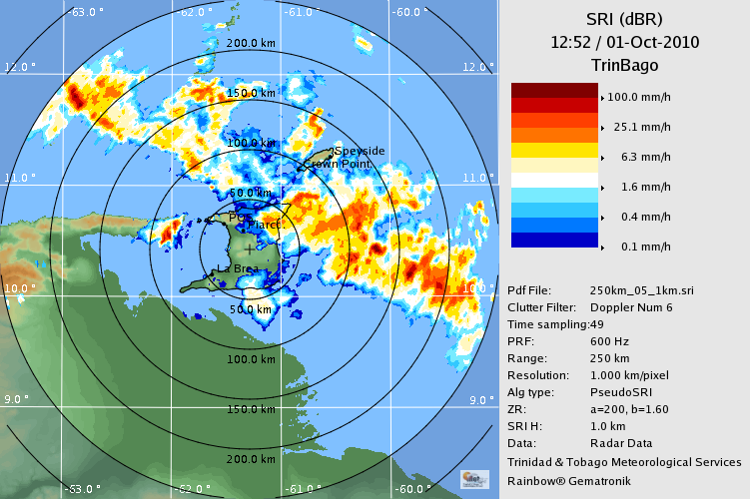
Figure 2: Trinidad radar –rainfall intensity -250km
6. In this context, the CMO Headquarters recommends that one radar system manager from each radar site, radar staff from the CIMH and staff from the CMO Headquarters collectively decide on a common set of products for use by (i) the public, media and natural disaster and emergency organizations (ii) aviation users, particularly Air Traffic Operations and (iii) the wider regional and international meteorological community. As part of such a discussion, the mode of providing the information to the special users, such as aviation, should be considered since various options are possible. It is also advisable that Internet-based facilities, such as Skype, be utilized for such exchanges as these have been proven to be very cost effective and efficient.
Radar Down-time:
7. As noted in paragraph 2, radar operations are close to normal in most locations. In some cases, however, there have been significant periods of “down-time”, outside of normal preventative maintenance. Barbados had more than one such period, while Guyana and Trinidad have had a few shorter periods. In almost every case thus far, the problems have not been with the radar unit itself, but with related systems, particularly power supply and humidity control systems. To protect them from damage in these cases, the radars have been designed to automatically shut down whenever irregularities in other systems occur. For example, the public electricity supply to the radar and the supply from the radar’s standby generator are both fed through high capacity Uninterruptible Power Supply (UPS) systems that do not seem able to adequately handle the often unstable and fluctuating local power that many locations experience. Once the radar system detects irregularities, it will shut down. A side result of this occurrence is that when the air conditioners also shut off, there is a humidity build up in the radar control room, which must be reversed before the radar will restart. The radar manufacturer should always be apprised of these problems and consulted in identifying solutions, especially as they have vast experience with similar nature situations around the world.

Maintenance Situation:
8. Within the CMO Radar Project, a number of radar technicians received training at the radar manufacturer’s facility in Germany. At the last two sessions of the Council, the CMO expressed concern that not all the personnel trained in radar maintenance by the radar manufacturer are in fact working with the radar in that capacity. The following table indicates the current situation with these trained maintenance personnel:
Country/Institution | Number of technicians trained | Status & Number of trained & operational technicians in the system – July 2011
Belize | (3)  - Albert Jones  - Raymond Crown  - Roy Thompson | (1)  1. Roy Thompson (Operational)  2. Albert Jones (retired)  3. Raymond Crown (retired)
Barbados | (4)  Barbados Met. Office  - Brian Murray  - Randolph Roberts  CIMH  - Marvin Forde  - Elvis Lashley | (2)  Barbados Met  - Brian Murray (Operational) [also an operational Meteorologist]  - Randolph Roberts (retired)  CIMH  - Marvin Forde (Operational)  - Elvis Lashley (Not retained by CIMH)
Guyana | (3)  1. Kelvin Samaroo  2. Garvin Cummins  3. Mortimer Salisbury | (2)  - Kelvin Samaroo  - Mortimer Salisbury [Civil Aviation personnel - irregular/limited availability for maintenance]  - Garvin Cummins [now in management]
Trinidad and Tobago | (3)  - Ronald Cassie  - Alison Lakhiram  - Jonathan Caesar | (2)  - Ronald Cassie (Operational)  - Alison Lakhiram (Operational)  - Jonathan Caesar [Non-operational - stationed in Tobago]
Total | (13) | (7)  Reduction summary:  3 retired; 1 not retained; 1 irregular/limited availability; 1 moved into management; 1 has never functioned as a radar technician

9. With the exception of just a few, all the technicians were completely new to radar maintenance. The CMO Headquarters is quite concerned about this overall situation and particularly about the situation in Barbados, where the only trained person from the Meteorological Service is now an operational Meteorologist, having to “split” his time between two very separate functions. Familiarity by trained technicians with the radar operations is critical to the longevity of the weather radars. In addition, other platforms in the overall weather observing system also require the full-time attention of trained and experienced technical staff. The Table above suggests that the situation in the other radar locations can quite easily become just as “unstable”. The CMO Headquarters already suggested to Council that there is the need for periodic refresher maintenance training or training of new maintenance personnel; but while it is under consideration within project proposals under the CIMH, funding sources have not yet been finalized (see Agenda Item 10(d)). A very clear and practical solution to the funding issue would be for the four Member States, Barbados, Belize, Guyana and Trinidad and Tobago to directly fund or contribute to the training of their technicians, which the CMO Headquarters can organize with the manufacturer.

Barbados Electromagnetic Interference and Image Masking:

10. During the radar site selection phase of the CMO Radar Project, every site considered in every country was examined for possible electromagnetic interferences between the radars and any other installations. Many ideal sites for a weather radar were discarded because of the possibility of such interference. Radar transmission frequencies were all approved by national authorities. The frequencies at which weather and other similar radars operate are reserved for these systems by the International Telecommunication Union (ITU) and its associated regional and national partner agencies. The ITU is the Geneva-based United Nations specialized agency for information and communication technologies, of which all CMO Member States are also Members. The use of the particular frequencies for any of the radars and other microwave radio links were all approved by the relevant national authorities.

11. From the time the Barbados radar first went into operation, radar imagery revealed very distinct interference from a land-based source at a bearing of approximately 265 degrees from the radar. The interference becomes more pronounced with distance from the radar, as seen in the Barbados images in Figure 1(b) and images in Figure 3. The interference shows up even when the radar echo returns are very intense, as seen the image of Hurricane Tomas in 2010. It is important to note that the interference blocks out information in the direction of and directly over the southern part of St. Vincent, which is a part of the forecast and warning responsibility of the Barbados Meteorological Service (see ANNEX V of CMC51 Doc 5). The Meteorological Service, the CIMH and the CMO Headquarters have all attempted to identify the source of the problem in consultation with local the telecommunication authority. It appears that the source of the interference could be a transmitter to the west of the radar that might be encroaching on the radar frequency. It is a well-known international problem being addressed by ITU that mobile telecommunication providers, in particular, do periodically encroach on portions of the radio spectrum that have been assigned for other uses. The radar manufacturer has recommended the purchase of a filter to eliminate the problem, possibly in combination with an adjustment to the radar frequency. However, it is also possible that the interference could be emanating from a fixed solid target in that direction. Therefore, before any decision is made on a filter, the Council should urge Barbados to have the interference problem thoroughly investigated by the appropriate authority in collaboration with the Meteorological Service and the CIMH, with a view to curtailing any illegal transmission if found to be the cause, or to recommend other feasible solutions.

12. Figures 3(c) and (d) also show a sector of missing data expanding to the southeast of the radar. This type of missing data is usually caused by tall objects close to the radar. In this case, the likely cause is the re-growth of tall trees that had been trimmed earlier. This is considered a temporary and easily corrected problem. Therefore it is highly recommended that the periodic cutting of the tall trees in the vicinity of the radar be a part of a permanent arrangement between the relevant Ministry and the owners of the properties.
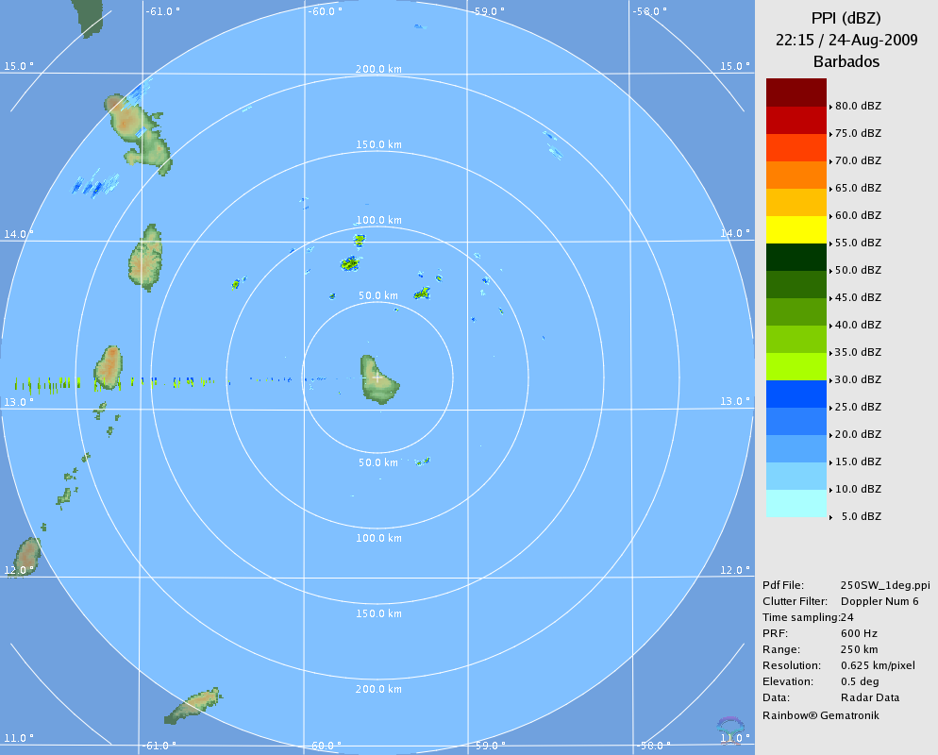
Figure 3(a): Barbados radar – EM interference

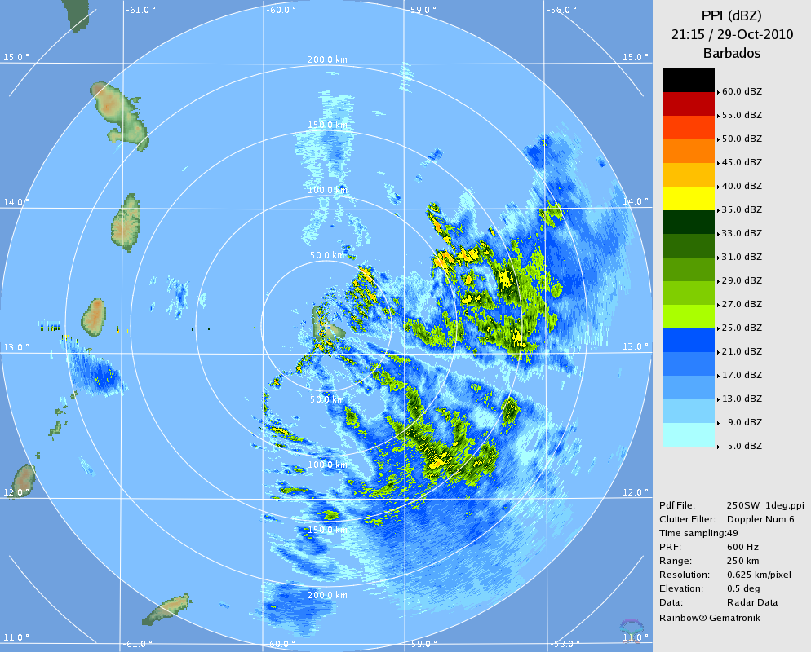 Figure 3(c): Barbados radar – Image masking

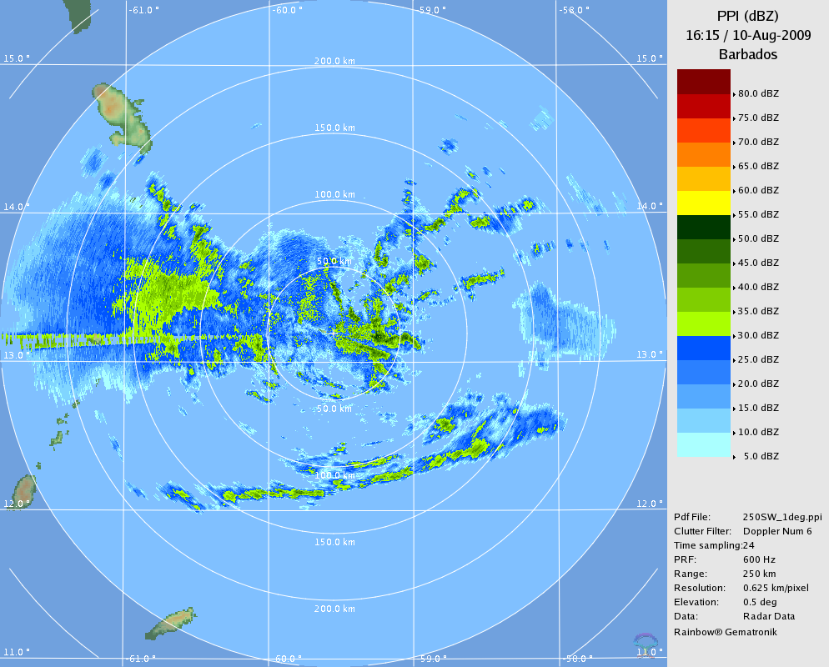
Figure 3(b): Barbados radar – EM interference

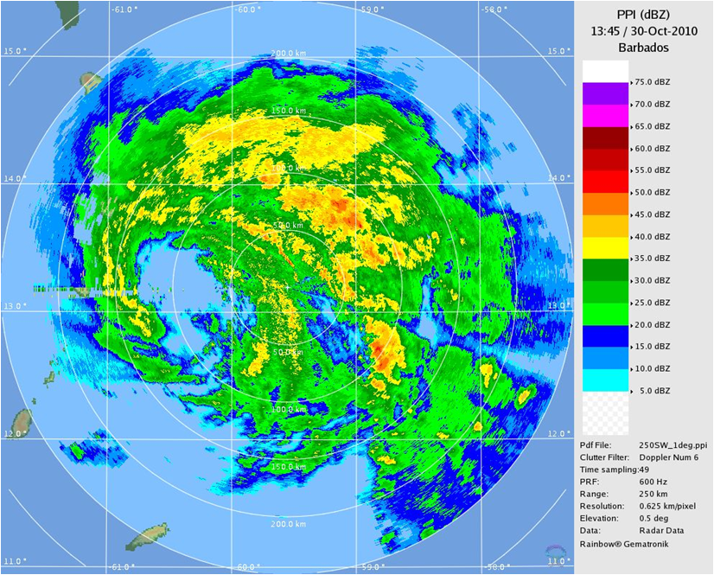 Figure 3(d): Barbados radar–Interference/masking – H. Tomas 2010

Availability of Network Radars within Regional Composite and WMO Hurricane Operational Plan

13. An imperative component of the Radar system is the “Network” aspect. Council will recall that Article 5.5 in each of the four Memoranda of Understanding between CARIFORUM and the four radar host Governments says that “The Government, …. agrees to make selected “real-time” data …available to other regional Meteorological Services, …. the regional composite radar image system ….and ….. the National Hurricane Center of the USA.” In the last year, there has been significant progress in making the “real-time” data available to other regional Meteorological Services with the noticeable improvements in some of the Websites, as noted above. However, there has not been nearly enough progress in getting the regional composite system working. The Council will note that the first stage of the composite was to be created by the integration of specific images from the four radars with the French radars in Guadeloupe and Martinique and the radar at the European Space Agency’s launch site at Kourou in French Guiana. When feasible, the radars in Jamaica and the Dominican Republic should be added to the composite, as depicted in Figure 4 below.

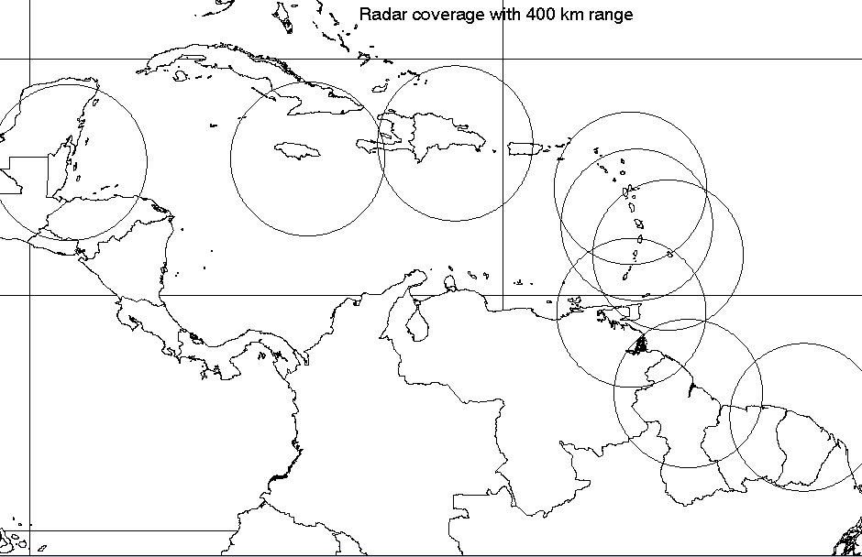
Belize
Jamaica
Dominican Rep.
Guyana
Fr, Guiana
Guadeloupe
Trinidad
Barbados
Martinique
Figure 4: Caribbean Radar Network (CMO/Météo-France)

14. The creation of the first phase was technically achieved, for the most part, with the inclusion of the Barbados and Trinidad radars. This occurs when the specific data from the CMO radars are automatically transmitted in a special WMO code [called BUFR code] at specific times to the composite centre in Martinique. The Composite centre integrates the data and retransmits a composite image. An example is shown in Figure 5. At that time, configuration of the transmission protocols were achieved with the Barbados and Trinidad radars, in which the radars’ workstations would automatically convert data to the WMO code and transmit via a two-way satellite system to Martinique. Before the same could be achieved in Belize and Guyana, a major change took place in the regional component of WMO’s Global Telecommunication System (GTS), in which the Meteorological Services’ data transmission via satellite was converted to a very high-speed terrestrial link, leaving the satellite for reception only.
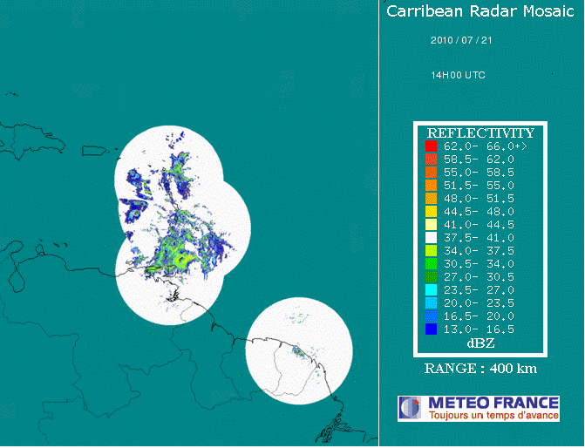
Figure 5: Early Composite – Eastern Caribbean- S. America sector (courtesy Météo-France)

15. The new routing of the radar data to Martinique is now via the GTS Regional Telecommunication Hub (RTH) in Washington, DC. Unfortunately, for reasons not yet determined, the radar data is not reaching Martinique under the new GTS configuration. The CMO Headquarters has organized manual tests to show that once the data reaches Martinique, the composite is created. Some new reconfiguration work is likely needed with all four radar workstations, including BUFR issues, while other work at the RTH side is also needed before the composite creation can resume. The Council should be aware that there is the feeling among some CMO Member States that insufficient emphasis is being placed on sharing radar data regionally and internationally, as required. Council should urge the radar host countries to take urgent measures to sort out these issues in collaboration with the CMO Headquarters.

16. Notwithstanding the technical issues with the creation of the composite images, there is also an international obligation to provide specific and highly detailed radar images and data to the WMO Regional Specialized Meteorological Centre for tropical cyclones in the North Atlantic, which is the US National Hurricane Center in Miami. It should be noted that the Hurricane Center’s access to the images available on the four websites is insufficient information for the regional hurricane warning system that all countries in the region are a part of. One of the Meteorological Services provides the Hurricane Center with a special Webpage for specific products. The four MoUs referred to calls for the Meteorological Services to operate Internet Servers or any agreed superseding technologies to provide radar data to the public and other users. The current recommended methodology to store and provide the special data is via the File Transfer Protocol (FTP) facility on the Internet Servers. At the moment, only one Service makes the data on its Server available via FTP. The CMO Headquarters has already circulated a set of products routinely needed by the Hurricane Centre, especially during the hurricane season.

17. The Council will recall that Jamaica acquired a Doppler weather radar from its own resources outside of the CARIFORUM/EU/CMO Project. That US-made radar was commissioned in 1999. Since that time, the Jamaica radar has periodically had its software and elements of hardware updated. It is expected that the latest software will include the capability to convert its data into the WMO BUFR code for international exchange. This will enable the Jamaica radar to be included in the CMO/Météo-France regional composite as this was provided for in the composite software from the inception. Once this capability is confirmed, the CMO Headquarters will assist Jamaica in this regard. For all the same reasons as above, it is also hoped that the Internet Server of the Jamaica Meteorological Service will also have FTP capabilities for the provision of radar data.

18. The Council would note that, as discussed under Agenda Item 5(b), the World Meteorological Congress has made the implementation of the WMO Integrated Observing System (WIGOS) as one of its five priorities in the period 2012 to 2016. Importantly, the WMO Regional Association for North and Central America and the Caribbean has decided to carry out a regional WIGOS demonstration project for the sharing of radar data. All the radars in the CMO Member States are expected to be an integral part of that demonstration project; therefore all the technical issues discussed above will have to be completed in the shortest possible time. It is also important for the Council and the Meteorological Services to recognize that global and regional Numerical Weather Prediction (NWP) models are increasingly ingesting special radar data, particularly Doppler-derived data. All CMO Member States that operate Doppler weather radars will be required, in the relatively near future, to provide its data in this regard. The current mode for providing data to the NWP models is via FTP. This is another important reason for urgent action to have FTP capabilities available.

(b). OPERATIONS OF THE CENTRAL RADAR SPARES DEPOT AND MAINTENANCE SUPPORT FACILITY AT CIMH

19. As part of the implementation of the CMO Radar Project, a new Central Spares Depot and Maintenance Support Facility was established at the CIMH. Each radar site was provided with two sets of radar spares, while a further set was supplied to the CIMH as central spares for the region. Personnel from the CIMH were also trained in radar maintenance at the SELEX facility in Germany to manage the Central Spares Depot and to provide maintenance support to any of the four radar sites if needed. Under an arrangement between the Barbados Meteorological Service and the CIMH, a CIMH technician assists in the routine maintenance of the radar in Barbados.

20. From the onset of this radar Project, the Council decided that the Central Spares Depot/Facility would operate on a supply and replace basis, so that if a radar site required any spares from the CIMH, which would normally be as an emergency, the CIMH would supply the component, and the Member State would pay the CIMH for the part so that the CIMH could purchase a replacement for the Depot/Facility.

21. The CIMH set up a computerized Central Spares Depot/Facility featuring:
- A computerized radar spares manifest;
- The costs of the spares;
- An inventory management system and the automated generation of shipping invoices (under development);
- The proposed spares Trust Fund value could be made available to the specific users to the management system.

22. Now that the Central Spares Depot and Maintenance Support Facility has been established, the CIMH will circulate to the relevant Member States, the Rules and Procedures of the Facility. It is important to note that the three-year warranty on each of the radars purchased by CMO from the manufacturer SELEX has virtually expired in all cases, therefore each site and the CIMH Depot must be fully ready to manage their maintenance issues on their own in the future.

23. In this regard, Council will recall that it agreed to a proposal for the establishment of the Trust Fund for the purchase of spares and associated shipping costs. The proposal from Barbados was that the four radar host countries, Barbados, Belize, Guyana and Trinidad and Tobago would contribute the sum of BD$10,000.00 per year to the Trust Fund to be held by the CIMH for the purchase of spares and associated shipping costs. The mechanisms for the establishment and operations of the Trust Fund have not yet been fully worked out. It is recommended to Council that it undertake a further discussion on this matter and provide guidance on the way forward, as appropriate.

C. CAYMAN ISLANDS WEATHER RADAR PROJECT

24. Paragraph 13 above described the new CMO Weather Radar Network, which now comprises the Doppler radars in Belize, Barbados, Guyana, Jamaica and Trinidad. It is hoped that other radars in the Dominican Republic, Puerto Rico and St. Maarten will be added to the Network, either directly within the current CMO/Météo-France system, or as part of the regional demonstration project for the WMO Integrated Observing System (WIGOS). This would lead to weather radar fence stretching along the South American coast to Trinidad, then north along the Eastern Caribbean Islands, then westward across the Greater Antilles to Jamaica and to Belize in Central America. To close the one major gap in the radar coverage, the CMO Headquarters is assisting the Government of the Cayman Islands with a project to install a new Doppler weather radar in Grand Cayman.

25. The Cayman Islands Doppler Weather Radar Project is estimated to cost Euro 4.6 million and is being jointly funded by the European Union and the Cayman Islands. Once implemented, the new Doppler weather radar would form the centrepiece of the Cayman Islands early warning system and would be integrated into the full CMO network, as depicted in Figure 6 below.

26. The Cayman Islands Airport Authority (CIAA) is the Project’s Implementing Agency. The CMO is providing scientific and technical support to the Project through the following two separate contracts, valued at Euro 99,040.00 and CI$546,000, between the CMO and the CIAA:
- Contract for the procurement, testing and commissioning of Radar and telecommunication systems, including the integration of the new radar in the existing Regional Radar Network and an internal distribution system;
- Civil Works design and supervision, including site selection, associated surveys and studies, and a meteorological training component.

27. The first contract was signed in October 2010. To undertake its part of the Project implementation, the CMO Headquarters augmented its personnel with two integrated teams comprising a hydrogeologist, radar meteorologists, telecommunication experts, engineers, architects and other construction specialists. As with many projects, the pace of project implementation has been slower than hoped for. The Radar tender was successfully completed and the civil works tender was launched in October 2011. The delays have caused the Cayman Islands authorities to request an extension of the Project’s implementation period from the European Union, which was granted. If there are no further significant delays, including weather-related delays, the new radar could be operational towards the end of 2012 or early 2013.

Belize
Jamaica
Dominican Rep.
Guyana
Fr, Guiana
Guadeloupe
Trinidad
Barbados
Martinique
Cayman Isl.

Figure 6: Cayman Islands Radar to provide complete Caribbean radar coverage

Action Proposed to Council:

28. The Council is invited to:

- Urge the Meteorological Service operating radars to publicize their Websites, including the availability of radar images, and for Services in neighbouring States to also publicize those sites and give access through their own Websites;
- Also urge the Radar States and CIMH to collaborate with the CMO Headquarters to collectively decide on a common set of products for use by the public, special users and the wider meteorological community;
- Note the efforts of the CMO Headquarters and the CIMH to source funding for periodic refresher maintenance training or training of new maintenance personnel. Due to the urgent need for this training, recommend to Barbados, Belize, Guyana and Trinidad and Tobago to directly fund or contribute to the training of their technicians;
- Urge Barbados to have the problem of interference with the radar signal thoroughly investigated by the appropriate local authority in collaboration with the Meteorological Service and the CIMH, with a view to curtailing any illegal transmission if found to be the cause, or to recommend other feasible solutions; and that arrangements be established to prevent or minimize masking of the radar beam by tall trees;

- Urge that high priority be given to sorting out all communication and Website issues to enable the regional radar composite to become fully operational, and for the US National Hurricane Center and other weather prediction centres to have full access to appropriate radar data;
- Note the operations of the Central Spares Depot and Maintenance Support Facility established at CIMH; undertake further discussions on the pros and cons for the establishment of and mechanisms for operating a radar spares Trust Fund, and provide guidance on the way forward, as appropriate.
- Note and provide any further guidance it may desire towards the implementation of the new Radar Project in the Cayman Islands.
___________

CMO Headquarters
October 2011

