

C A R I B B E A N

M E T E O R O L O G I C A L

O R G A N I Z A T I O N

**CARIBBEAN METEOROLOGICAL COUNCIL** **Doc. 10**

FIFTY-THIRD SESSION

Bridgetown, BARBADOS, 18-19 NOVEMBER 2013

##### OTHER PROJECT UPDATES AND PROPOSALS

(Submitted by the Coordinating Director)

**Introduction**

1. Weather, climate and water are at the heart of the environmental issues affecting the planet. National Meteorological and Hydrometeorological Services (NMHSs) in the Caribbean and the world over must provide accurate information, analyses and timely forecasts of hazardous weather-related conditions that affect the sustainable development of their nations in the short term. At the same time, the NMHSs must provide the appropriate data and scientific-basis for studies on the long-term potential impacts of both natural and human-induced climate change on the environment. The contribution of meteorology and related sciences to these global studies is driven by the constant adaptation to and use of technological changes and opportunities.

2. In this regard, many of the projects being undertaken or planned have observational and scientific data information components involving the use of new or modern technologies. This is primarily an information document intended to keep the Council up-to-date on the progress of implementation on any on-going projects of this nature, which involve CMO Member States and partner organizations, such as the *World Meteorological Organization* (WMO) and the *Association of Caribbean States* (ACS). The document will also inform the Council and seek its guidance, on activities or proposals for new projects.

(a) WMO CARIB-HYCOS Project – Project Termination – Future Activities?

3. In 1993, the WMO launched the ***World Hydrological Cycle Observation System*** (WHYCOS). Its aim has been the development of water resources information systems to assist Member countries to improve their water management, mitigate the impact of water-related disasters such as floods and droughts and contribute to regional and global studies of the impact of climate change on water resources. WHYCOS was developed through a series of 17 regional HYCOS components. **Carib-HYCOS** was one of these regional projects (see **Figure 1**). On paper, Carib-HYCOS has been organized into two components, one addressing the needs of the Caribbean Island countries (CIC) and the other, the needs of the mainland countries of the Caribbean Basin. No project has yet been developed for the mainland countries. The Islands Componentof **Carib-HYCOS**, on the other hand, was implemented between 2008 and 2012, officially closing in November 2012.

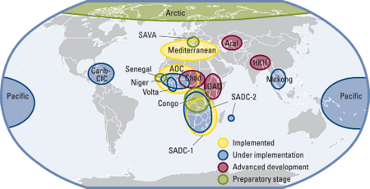

**Figure 1**: WMO HYCOS Projects around the world

4. Eleven Caribbean Island States participated in the Project, namely ***Antigua and Barbuda*, *Barbados***, Cuba, ***Dominica***, the Dominican Republic, Guadeloupe, Haiti, ***Jamaica***, Martinique, ***Saint Lucia*** and ***Trinidad and Tobago***. The Project was supervised by WMO, with the *Institut de Recherche pour le Développement (*IRD) of France as the Executing Agency. The Project Management Unit (PMU) was located in Martinique. It was assisted by the ***Caribbean Institute for Meteorology and Hydrology*** (CIMH) and the *Instituto de Meteorologia* (INSMET, Institute of Meteorology) of Cuba for the English- and Spanish-speaking countries respectively. As a regional institution, the ***CMO*** has been supporting Carib-HYCOS, particularly to ensure that the Hydrological Services of its Member States, as well as the CIMH, play an integral part in this important activity. The ***CMO HQ*** was on the Project’s Steering Committee (PSC).

5. The project was co-financed by the Regional Council of Martinique, the General Council of Martinique and the FEDER (European Funds for Regional Development) for a total of 1,317,000 Euros with an additional 1,200,000 Euros as the IRD`s in-kind contribution, and 400,000 Euros as countries’ in-kind contribution.

6. Project achievements, particularly after 2010, included:

* Purchasing and installing hydrological stations and related material to upgrade existing hydrological networks;
* Providing each National Hydrometeorological Service with a centralized database management system;
* Running training programmes on software installation, instrument installation and maintenance;
* Creating a regional hydrometeorological database, an Internet Website and an FTP server to collect and transfer data remotely.

7. Since the termination of the Project, consideration has been given to a possible new phase of activities, if donors can be found. A concept document would be developed by WMO and partners. In the interim, institutions such as the CIMH and INSMET will continue HYCOS-type activities in their respective countries of influence.

**(b) Finland Initiative - Strengthening Hydrometeorological Operations and Services in the Central America and the Caribbean (SHOCS**)

8. Between the years 2001 and 2004, the Government of Finland funded the SIDS-Caribbean Project titled “*Preparedness to Climate Variability and Global Change in Small Islands States, Caribbean Region*”. As a continuation of its activity among the Caribbean Small Island Developing States (SIDS), the Ministry for Foreign Affairs of Finland (MFA) provided 500,000 Euros to carry out a *needs assessment and feasibility study project*entitled ***“Strengthening Hydrometeorological Operations and Services in the Central America and the Caribbean (SHOCS)”***. The Project was implemented by the Finnish Meteorological Institute (FMI) under the direction of the *Association of Caribbean States* (ACS), in collaboration with WMO and CMO. The CMO is a member of the Project Board, along with the ACS, WMO, the Caribbean Emergency Management Agency (CDEMA) and FMI.

9. The CMO Member States that participated in the feasibility study project were Antigua & Barbuda, Barbados, Belize, Dominica, Grenada, Guyana, Jamaica, St. Kitts & Nevis, Saint Lucia, St. Vincent & the Grenadines and Trinidad & Tobago. The other States were the Bahamas, Cuba, the Dominican Republic, Haiti and Suriname. The beneficiaries of the Project have been the Meteorological and Hydrological Services (NMHS) and Disaster Management Agencies of the above States, along with the CIMH as a regional institution.

10. The feasibility phase of SHOCS, now called Phase I, was implemented between 2010 and 2012. Before the end of Phase I and continuing through much of 2013, a Phase II was formulated between the MFA of Finland, FMI and the other members of the Project Board.

11. The Overall Purpose of SHOCS II has been formulated as:

To e*nhance the role and strengthen the capacity of National Meteorological and Hydrological Institutions and Disaster Management Agencies in ACS Member States in the provision of early warning services and preparedness to mitigate impacts of natural hazards.*

12. Four themes have been identified as priority result areas in the Work Plan for SHOCS II:

**Result 1:** *Improved operational capacity of the Caribbean SIDS weather observation network.* *Activities could include:*

* 1.1 Enhancement of Automatic Weather Station (AWS) networks (including the acquisition of, or upgrade to non-corrosive AWS technology
* *Any restoration of AWSs, or new ones, must be accompanied by the compilation of the stations’ metadata; metadata must be made widely available at the local, regional and WMO levels.*
* 1.2 Enhancing tools for weather forecasting
* SmartMet workstations: 3 Main Sites (MS) and 7 or 8 Remote Sites (RS)
* *Main Sites: Cuba, Barbados and Antigua& Barbuda*

*Remote Sites: Belize, Guyana, Grenada and Saint Lucia. Decision on other potential RS sites to be made after further analysis.*

**Result 2:** *Improved capacity for communication of risk information and early warnings*

* Coordination between NMHSs and Disaster Management Agencies (DMAs);
* Workshop on regional coordination of Early Warning System (EWS) products, etc;
* Introduction of relevant protocols, such as the Common Alerting Protocol (CAP), etc.

**Result 3:** *Improved capacity to provide specialized services to the society.* Activities to date include:

* 3.1 Continue QMS training with focus on auditors, link this to certification at CIMH;
* A QMS Auditor workshop, (Trinidad & Tobago, December 2013);
* CMO Headquarters to seek CMC endorsement for a regional pool of QMS Auditors, including methodology and funding mechanism.
* 3.2 Developing harmonized visualization and dissemination of early warnings.
* Preliminary discussions at CMO/DMS (Nov 2013) then possible workshop.
* 3.3 Support to the development of Caribbean Climate Services
* This will be formulated based on activities and proposals emanating from WMO, CMO/CIMH and other regional organizations.
* 3.4 Training on TV-broadcasting of severe weather information (including some software)
* High interest by at least 10 NMHSs, including Cuba
* Potential trainers being reviewed

**Result 4:** *Enhanced Climate monitoring and Services through an internet portal*

* To provide an internet portal to present temporal and spatial variability of climate data. The user interface will be open to public use;
* Demonstrate the strength and impacts (casualties, physical and economical) of extreme hydro-meteorological conditions (hurricanes, tropical storms, drought, flooding etc.) based on existing reports and climate data;
* To provide operational medium and long-term weather and climate outlooks using medium and long term NWP-prediction results (based on CIMH RCC activities).

13. Other activities under consideration for SHOCS Phase II include:

* Weather radar training:
* Maintenance training for technicians;
* Meteorological staff training.
* integrating on-line lightning data with other data for severe weather forecasting;

- Acquisition of on-line lightning detection data for a pilot period (option for 1-3 new lightning detection sensors).

14. As discussed in Doc 3(a) under Agenda Item 3, there are some CMO Member States that have been categorized by the *Organisation for Economic Co-operation and Development* (OECD) a**s “More Advanced Developing Countries and Territories”. These Member States are no longer eligible for** *Official Development Assistance (ODA)* by the OECD and countries that utilize the OECD’s categories. The MFA Finland utilizes the OECD list. Therefore, in the case of the SHOCS II project, those CMO Member States that fall into this category can continue to participate and are encouraged to participate in SHOCS activities utilizing their own funds or funds from other sources.

**(c) Lightning Detection System**

15. For some years, the CMO Headquarters indicated its intention to establish a ground-based *Lightning Detection System* in the region. Initially, the intention was explored in partnership with the Meteorological Service of France (Météo-France). The CMO HQ has studied this system in great detail and is of the opinion that such a system is very necessary in the Caribbean. The 52nd session of the Council (November 2012) was provided with a visualization of a long-range lightning detection system. With these long-range systems, lightning data can be acquired over the oceanic areas associated with weather systems that are well outside of radar range. At this distance, the resolution of the data at these distances is not critical. At the shorter distances, however, higher accuracy and thus a high resolution detection are both necessary, especially if lightning data is required for specific sensitive locations and activities. Although the long-range systems still provide very useful inform at the shorter ranges, they are best used in conjunction with short-range systems. Therefore, for this higher resolution to be achieved, it will be necessary to install some lightning sensors along the island chain to allow for adequate triangulation using the commonly known phenomenon “lightning spherics”.

16. As a starting point for discussion, it has been necessary to demonstrate the value of long-range lightning detection and location systems to the National Meteorological and Hydrometeorological Services (NMHSs) in CMO Member States. The CMO headquarters therefore organized with the Vaisala company, a ***free real-time operational “field” trial***, lasting several months and covering the Caribbean, northern parts of South America and the Atlantic Ocean as a subset of its global system. The NMHS Forecast Offices and the CIMH were provided with the appropriate software and access to Vaisala’s global network to be used in conjunction with other observing and forecasting tools. A screen shot of the Vaisala’s system, as used in the trial, is shown in **Figure 2** below. The CMO also provided links to other locations for the acquisition of lightning data.

17. It is also important to note that the next generation of the *Geostationary Operational Environmental Satellite* R-series (**GOES-R**) will include a new capability for total lightning detection (cloud and cloud-to-ground flashes) from the Geostationary Lightning Mapper (GLM). However, the planned launch of the first GOES-R series is late 2015 or early 2016. The first GOES-R will be placed in orbit at 137°W with the second at 75°W. The footprint of a satellite at 137°W will only cover the Western Caribbean. It will therefore be sometime before satellite-based lightning detection is fully available.

18. There are three basic options for consideration for an island-chain set of ground-based sensors; (i) the number and location of processing units for the data; (ii) the mode of transmission among the countries involved and (iii) the method of paying for the system. A further issue for consideration is to build onto existing lightning systems owned by non-regional entities and then subscribe to the service, as is done by many countries. One such possibility has already been identified under the SHOCS II Project, as noted in paragraph 13 above. Under this scenario, a suitable mechanism to subscribe to the system would need to be considered by the Council.

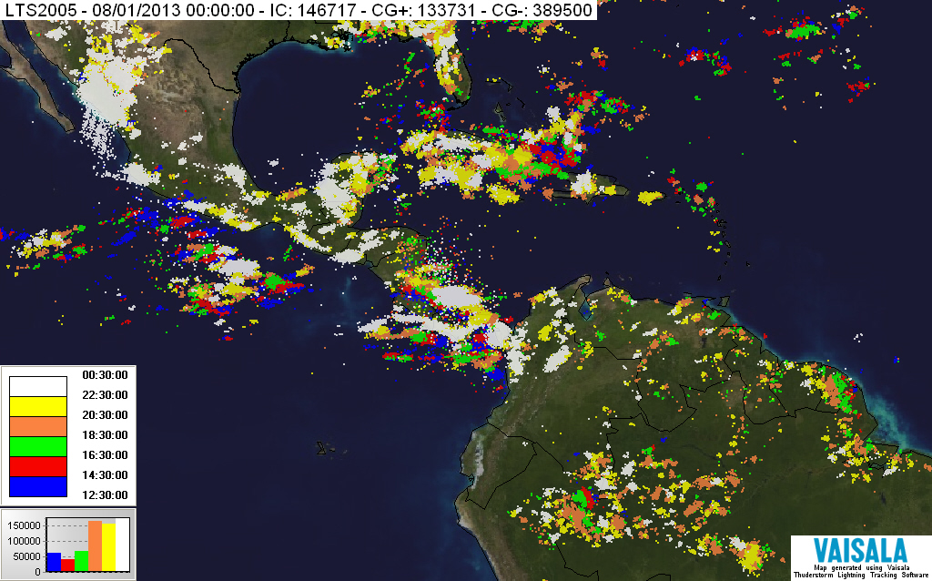

**Figure 2**: Vaisala’s Global Lightning Detection System (August 2013)

**(d) Other CMO Project Proposals**

(i) **Regional component of the WMO Integrated Global Observing System (WIGOS)**

19. Under Agenda Item 5, Council was provided with the latest plans for implementation of the region component of the *WMO Integrated Global Observing System* (WIGOS). WIGOS is an all-encompassing approach to the improvement and evolution of WMO’s global observing systems. The implementation of the WIGOS is very closely related to the new ***WMO Information System*** (WIS), both of which are essential to all technical and scientific activities of Meteorological Services in the Caribbean and worldwide. CMC53 Doc. 5 provides details of the role of the CMO Headquarters in the implementation of WIGOS and WIS.

(ii) **A Caribbean initiative in the field of early warning systems, integrating Carib Risk Cluster objective**

20. In 2010, WMO launched a Caribbean initiative to strengthen hydrometeorological early warning systems, putting the emphasis on climate-related meteorological, hydrological, sea, and coastal risks. As part of that initiative, WMO published a reference paper entitled “*Strengthening of risk assessment and multi-hazard early warning systems for meteorological, hydrological and climate hazards in the Caribbean*.” The objective of WMO’s initiative is to improve regional cooperation, building capacities amongst the stakeholders working in this field in the region.

21. This objective directly relates to the objectives of the European Union’s ***INTERREG* program. The *INTERREG IV "Caribbean"* program** fosters collaborations among several institutions in both the Francophone and non-Francophone Caribbean. The **INTERREG program** is funding a project entitled “***Caribbean Cluster on Natural Risks and Risks from the Sea***”, hereafter referred to by its acronym **Carib Risk Cluster.** It is being implemented by the ***General Council of Martinique.***

22. A major component of the **Carib Risk Cluster project is the** implementation of Météo-France “**SHERPA**” initiative. SHERPA’s aims are:

* Improving the availability of upfront meteorological expertise, made available to Météo-France, for an exclusive use by neighbouring Caribbean National Meteorological Services, including Haiti.
* Setting up an exchange platform, in real time, to improve coordination between neighbouring Caribbean territories, for a better management of extreme meteorological events, especially outside or on the periphery of tropical cyclones.

23. SHERPA is a secured WEB platform (Extranet) to share and make available products and information useful to the analysis, and to the forecasting of potentially dangerous meteorological phenomena in the Caribbean, including

* Products to improve the use of observation data (radars, wave riders, satellite imagery…);
* Numerical Weather Products based on the French models (ARPEGE/ALADIN) and on the ECMWF models.

24. To provide access to and use of Météo-France’s **SHERPA**, the General Council of Martinique, Météo France, and CMO will sign a collaborative Memorandum of Understanding. Under this MoU, the CMO will, among other things:

* Promote the SHERPA initiative, within Carib Risk Cluster, to the CMO Member States;
* Help partners define and put in place support necessary to the implementation of Extranet SHERPA;
* Ensure feedback of information from NMHS in CMO Member States;
* Take measures to ensure the non-redistribution of shared Extranet data or products without prior consent from Météo France.

25. It is important to underscore that the use of Météo-France’s SHERPA does not prevent the NMHSs in CMO Member States nor the Organs of the CMO from using any other platforms that may have a similar purpose since SHERPA is simply a tool used by meteorologists in the forecast and warning process. As part of the **Carib Risk Cluster project,** Météo France conducted a workshop from 29-31 October 2013 at the CIMH in Barbados. It was attended by staff of eight NMHSs in the region.

(iii) **An Education and Training initiative – The GLOBE Program**

26. The ***Global Learning and Observations to Benefit the Environment*** (GLOBE) *program* is a worldwide hands-on, primary and secondary school-based science and education program. GLOBE's vision promotes and supports students, teachers and scientists to collaborate on inquiry-based investigations of the environment and the Earth system, working in close partnership with the [*National Aeronautics and Space Administration*](http://www.nasa.gov/) (NASA), the *National Oceanic and Atmospheric Administration* (NOAA) and the *National Science Foundation* (NSF) of the USA in the study and research about the dynamics of Earth's environment.

27. **WMO** and **NASA** have agreed terms of reference allowing the GLOBE Program and WMO to collaborate on common goals. These include increasing international environmental awareness, developing scientific understanding of the global environment and supporting improved achievement in science and mathematics education around the world.

28. Through the GLOBE Program, NASA and WMO will also work together to enhance general public understanding of weather, water and issues such as climate change. Initial plans for collaboration include involving ***National Meteorological and Hydrological Services*** (NMHSs) in the implementation of regional GLOBE Program activities, such as teacher training events and working with schools that lack access to computer technology.

29. Such activities will expand opportunities for NASA, the University Corporation for Atmospheric Research (UCAR), GLOBE and WMO to introduce scientific, computer and communication technologies in classrooms all over the world. In addition, WMO will encourage NMHSs and Regional Meteorological Centres to increase the number of scientists working with GLOBE teachers and students. Another noteworthy objective is the promotion of student scientific research to better understand the Earth as a system. The GLOBE Program has reached over one million students in more than 19,000 schools and trained some 37,000 teachers.

30. For some time now, the CMO Headquarters has been thinking of a programme to introduce weather, climate and water to high schools in the region, in which they could run simple weather/climate stations and receive some basic instructions from the Met Services. Such meteorological instruments would be properly sited at schools with students taking readings and doing simple maintenance. When WMO got involved with the GLOBE programme, it seemed to be the perfect platform to pursue these ideas. Council is asked to discuss the pros and cons of pursuing such a programme in high schools in Member States, through the WMO/GLOBE initiative or otherwise.

**ACTION PROPOSED TO COUNCIL**

31. **The Council is invited to**:

Note the updated information and provide any guidance necessary on (i) *WMO Carib-HYCOS Project*, (ii) The Finland-funded Project for the *Strengthening Hydrometeorological Operations and Services in the Central America and the Caribbean* (SHOCS II), (iii) Lightning Detection System and (iv) other projects planned by or involving the CMO Headquarters, including guidance on the *GLOBE* program.

CMO Headquarters

November 2013