

C A R I B B E A N

M E T E O R O L O G I C A L

O R G A N I Z A T I O N

**ANNUAL MEETING OF DIRECTORS OF METEOROLOGICAL SERVICES Doc. 4**

Kingston, JAMAICA, 22NOVEMBER 2014

**OPERATIONAL MATTERS**

(Submitted by the Coordinating Director)

## INTRODUCTION

1. Several matters that are particularly related to the operations at National Meteorological Services (NMSs) are raised or addressed in this document. Some of the matters may be of immediate concern or require immediate action on the part of the NMSs, while others are raised to create awareness of issues upcoming in the near future.

## A. WMO Annual Global Monitoring

2. The WMO Manual on the Global Telecommunication System (GTS), in its Attachment 1‑5, refers to a plan for monitoring the operation of the World Weather Watch (WWW). This plan includes provisions for the internationally coordinated monitoring of the operation of the WWW on a non-real-time basis.

3. The Annual Global Monitoring (AGM) is carried out in October each year. The WWW centres are invited to monitor SYNOP, TEMP, PILOT, and CLIMAT reports from the *Regional Basic Synoptic Network* (RBSN) stations in accordance with the responsibility taken for the exchange of data on the GTS:

* The **National Meteorological Centres** (NMCs) should monitor data from their own territory:
* **Regional Telecommunication Hubs** (RTHs) should at least monitor data from their associated NMCs, and possibly from their own Region:
* **World Meteorological Centres**(WMCs) and RTHs located on the Main Trunk Network (MTN) should monitor the complete global data set.

4. The results of the AGM make it possible to compare the availability of the reports received from RBSN stations at the NMC responsible for inserting the data in the Regional Meteorological Telecommunication Network (RMTN), at the associated RTH and at MTN centres. The differences in the availability of data between centres are generally due to the following main reasons: (i) differences of requirements in the reception of data, (ii) shortcomings in the relay of the data on the GTS, (iii) data not monitored due to differences in the implementation of the monitoring procedures at centres.

5. There are ten (10) Members States of the Caribbean Meteorological Organization whose National Meteorological Service (NMS) are RBSN stations. These are Antigua and Barbuda, Barbados, Belize, Cayman Islands, Dominica, Grenada, Guyana, Jamaica, Saint Lucia and Trinidad and Tobago.

6. WMO's data archive at **ftp://ftp.wmo.int/GTS_monitoring/AGM/To_WMO/201310/** shows only Dominica and Trinidad and Tobago submitted results of their monitoring for the AGM in 2013. Hence, the results presented in Table 1 for the monitoring of SYNOP, TEMP and CLIMAT below reflects for the most part, the reports from the RTH and MTN centres.

|  |  |  |  |
| --- | --- | --- | --- |
| **Country** | **SYNOP**  **(%)** | **TEMP**  **(%)** | **CLIMAT**  **(%)** |
| Antigua and Barbuda | **90-100** | **N/A** | **N/A** |
| Barbados | **90-100** | **90-100** | **90-100** |
| Belize | **90-100** | **90-100** | **90-100** |
| Cayman Islands | **45-90** | **1-45** | **Silent** |
| Dominica (Canefield) | **45-90** | **N/A** | **N/A** |
| Dominica (Melville Hall) | **45-90** | **N/A** | **N/A** |
| Grenada | **90-100** | **N/A** | **N/A** |
| Guyana (Cheddi Jagan) | **45-90** | **N/A** | **Silent** |
| Jamaica (Kingston) | **90-100** | **Silent** | **Silent** |
| Jamaica (Montego Bay | **90-100** | **N/A** | **Silent** |
| Saint Lucia (Hewanorra) | **90-100** | **N/A** | **N/A** |
| Saint Lucia (Vigie) | **45-90** | **N/A** | **N/A** |
| Trinidad and Tobago (Crown Point) | **45-90** | **N/A** | **N/A** |
| Trinidad and Tobago (Piarco) | **90-100** | **90-100** | **Silent** |

Table 1: Results of the 2013 Annual Global Monitoring

7. The results also show that the stations at Kamarang (81005), Ebini (81010) in Guyana, were silent during the reporting period. The RTH and MTN centres results also indicated that between 1-45% of the expected reports were received from the stations at Lethem (81006) and Kaieteur Falls (81080).

8. The Headquarters Unit reminded the RBSN stations of the AGM in August of this year and offered assistance in reporting the results to WMO. By the time of completion of this Report CMO had provided assistance to the Cayman Islands, Dominica and Barbados in the completion of their AGM reports.

**B. Migration away from Traditional Alphanumeric Code Forms**

*Migration to Table Driven Code Forms*

9. The Meeting will recall that migration away from Traditional Alphanumeric Code Forms to Table Driven Code Forms (TDCFs) has been discussed at several previous meetings of the Directors of Meteorological Service starting from 2008. The WMO migration plan called for the complete migration of the SYNOP, TEMP, PILOT and CLIMAT code forms (category 1 observations) to BUFR **by November 2010** after a period of dual code forms transmitted on the Global Telecommunication System (GTS), which started from November 2005. Member States of WMO were requested to name a national focal point and to develop their migration plan accordingly.

10. One of the reasons for the change to TCDFs was difficulties experienced by Meteorological Services under the traditional alphanumeric code form to assign station numbers because there were insufficient WMO station identifiers available to assign a unique number to each station in a country and that this was hindering the international exchange of information. The Commission for Basic Systems (CBS) addressed this issue by permitting more station identifiers to be defined within the TDCFs.

11. Meteorological Services that do not make the change will not be able to access observations from observing stations that are allocated a station number from the extended range. They will experience a reduction in the number of observations available to them as changes to observing systems create information that cannot be represented in the Traditional Alphanumeric Codes (TACs). It must be noted that, at present, no Meteorological Service of CMO Member States has migrated to TDCF (MTDCF) and the migration to TDCF is scheduled to be completed in November 2014.

12. Meteorological Services of Member States of the Caribbean Meteorological Organization operate five (5) Cooperative Hurricane Upper-Air Stations (CHUASs) in Barbados, Belize, the Cayman Islands, Jamaica and Trinidad and Tobago. These stations supply observations to the global meteorological community and especially to the US National Hurricane Center (NHC) and the national hydrometeorological service (NHMS) of each participating Caribbean country, in support of its hurricane forecasting activities and to provide data sets for research. Bilateral agreements between NOAA and the NHMSs for the operation of these stations were established as early as 1969. The terms of each agreement vary, but the basics include provision of equipment, spare parts and expendables, and assistance with major maintenance and training.

13. Communication between the CMO and the Office of Operational System, Maintenance Branch of the United States National Weather Service to ascertain the migration of CHUAS to report the upper-air observations in BUFR has revealed that, due to the limitations of the IMETOS software capability used in the CHUAS network, there are no plans to invest resources in upgrading the software package. There are plans for a complete overhaul of the CHUAS network during the Untied States of America 2015 fiscal year. The overhaul is to include new 403 MHz radiosonde systems, which includes antennas, computers, radiosondes and operating software, which will generate the BUFR code.

14. For a Meteorological Service to transmit category 1 observations in BUFR formation, both WMO and the Regional Telecommunication Hubs (RTHs) in Maracay and Washington need to be informed of the impending change in transmission. The WMO header for observations in BUFR format is different to the headers for the traditional alphanumeric code forms. Therefore new WMO headings (T1T2A1A2ii) will have to be developed for the transmission of the observations using Attachment II-5 from Part II of WMO No. 386 - Manual on the Global Telecommunication System. The pertinent tables within the attachment for the creation of the WMO Header are as follows:

**T1 : - TABLE A**

**T2 : - TABLE B3**

**A1 : - TABLE C6**

**A2 : - TABLE C3**

**ii : - See paragraph 2.3.2.2 for definition and use.**

15. A '*NWS Request for Change (RC) Form*,' has to be completed to inform the RTH of the observations being transmitted in BUFR format. A digital copy form is available at **http://www.nws.noaa.gov/iscs/baseline.html**. After completing the "Cover Sheet" and "Part A Data Products and Supplement," the form is to be submitted to the RA IV Action Focal Points located on the website of the URL above. This process must be completed at least two months before observational data is to be transmitted. The RTH will inform WMO of the new headers which will be transmitted and the old headers which will be deleted.

*Migration of Aviation Code Forms to XML*

16. Migration of METAR, SPECI, SIGMET and TAF is to be completed by November 2016. Testing of the transmission of the observations and forecasts via the Aeronautical Fixed Telecommunication Network (AFTN) occurred in 2009 and 2010 with some success. WMO has developed its Logical Data Model (LDM) in Unified Modeling Language (UML) for the aviation code forms, but the International Civil Aviation Organization (ICAO) would like the data in eXtensible Markup Language (XML). Therefore, there has been discussion between WMO and ICAO for an automated translation from UML to XML. Testing started in June 2012 and will continue for a further three years. It is intended that XML data will not be read directly by humans as all visualisations will be through the use of computers.

*Possible Impacts of the Migration*

17. Since the migration to TCDFs and XML will affect the whole meteorological observation data flow, WMO recommended a lot of attention and commitment by NMHSs. Hence, it recommends that the following activities must be undertaken and the outcome listed in the National Plan, which must be implemented:

1. Analyze and identify impacts of migration on national operation;
2. Identify some necessary (but usually limited) financial and staff resources;
3. Define and run a national training programme on TDCF and XML;
4. Define and perform software adjustments *(*preparatory corrective actions at National Centres to avoid missing incoming data).

18. There is no “one size fits all” migration plan available to the Meteorological Services of CMO Member States. Meteorological Services that manually plot meteorological charts will feel a greater impact of the migration to TDCF since the job descriptions and the functions of the staff used to plot the charts will have to be changed. Further, equipment would have to be procured, which will allow for the decoding and plotting of the observations in BUFR format. There is one change, however, which will be common to all of the Services. The registers which are used to record the observations will eventually have to be changed as new staff are introduced and trained, and as the Caribbean Institute for Meteorology and Hydrology ceases to teach the SYNOP, METAR and SPECI code forms.

**C. Quality Management Systems**

*Aeronautical Quality Management System*

19. The International Civil Aviation Organization first recommended that the Meteorological Authority be certified as ISO 9001 compliant in November 2001 and it was expected that this recommendation would become a standard in November 2010. However, by November 2013, the recommendation for ISO compliance was discontinued and the recommendation stated:

2.2.6 **Recommendation —** *Demonstration of compliance of the quality system applied should be by audit. If non-conformity of the system is identified, action should be initiated to determine and correct the cause. All audit observations should be evidenced and properly documented.*

20. In addition, the Sixty-fifth meeting of the WMO Executive Council (Geneva, 15‑23 May 2013) was informed of an agreement in principle between the relevant WMO and ICAO Secretariats that Member States not complying with the Recommended Practice of obtaining certification in accordance with the ISO 9001 Standard should, as a minimum, provide evidence for having achieved the following milestones:

1. Evidence of a contractual arrangement between the Meteorological Authority and Service Provider with clearly established responsibilities;
2. Availability of quality policy, quality manual and complete set of work instructions/process descriptions at all workplaces, and routine use of these documents by staff;
3. Documented evidence of user consultation and feedback (publications, questionnaires, records of user meetings, actions stemming from these);
4. Evidence of corrective and preventive action processes; and
5. An internal audit plan, audit reports and documented follow-up decided by a Management Review meeting.

21. The items enumerated in the above paragraph are all the elements of a quality management system (QMS) which has been implemented but not ISO 9001:2008 certified. At the conjoint ICAO/CAeM Met Divisional Meeting, as stated in DMS2014 Doc 5, paragraph 29, the proposal to amend Annex 3/Technical Regulation [C.3.1] to change the recommendation to a standard, was agreed. The amendment will go before the ICAO Air Navigation Commission for approval before it becomes a standard in November 2016.

22. It is expected that in the future, when Contracting States of ICAO have implemented a quality management system for the provision of meteorological services to aviation, the ISO certification will be required. At this time ISO 9001:2008 is under revision, which is a normal process since all standards are reviewed every five (5) years to establish if a revision is required to keep it current and relevant for the marketplace. It is expected that the new standard ISO 9001:2015 will be published in September 2015 and all Meteorological Services which are certified under ISO 9001:2008 will have three years from the date of publication, to complete the new documentation and seek certification under the new standard.

*WMO Quality Management Framework*

23. WMO Congress in 2003, by its Resolution 27, decided that WMO should work toward a *Quality Management Framework* for National Meteorological and Hydrological Services that would eventually include and develop technical standards, quality management systems including quality control, certification procedures and the provision of early and continuing relevant advice to Members on developing their quality management systems.

24. The WMO Strategy for Service Delivery, which is available at **http://www.wmo.int/pages/prog/amp/pwsp/documents/WMO-SSD-1129_en.pdf**, refers to the QMS as a vital approach to all service areas and steps must be undertaken to promote QMS in the provision of services which have important safety implications, such as marine, hydrology, disaster risk reduction, etc. Quality management is becoming a requisite function and managerial practice to be promoted through different service delivery areas. The new ISO 9001:2015 Standard has some fundamental changes, including a focus on leadership and risk management, which would necessitate a retooling of the existing QMS processes and procedures with National Hydrometeorological Services. The WMO Congress in 2015 will provide policy guidance on the future of the WMO quality management framework.

**D. Regional Telecommunication Issues**

25. The Region has included in its WMO Integrated Global Observing System (WIGOS) Implementation Plan, a Project to get observational data from Automatic Weather Stations (AWSs) onto the Global Telecommunication System. However, as indicated in paragraph 10 above, there are insufficient WMO station identifiers available to assign a unique number to each station in a country using the traditional alphanumeric code forms.

26. The station numbers have the form of '**IIiii'**, where '**II'** is the block number and '**iii'** is the station number. The convention used for the assignment of station numbers is to divide the area to be covered into horizontal strips (e.g. one or several degrees of latitude). Where possible, station numbers within each strip should increase from west to east and the first figure of the 3-figure station number increases from north to south. The list of station numbers assigned to Member States of CMO, as stated in *WMO No. 9, Volume A - Weather Reporting*, is shown in Table 2:

|  |  |
| --- | --- |
| **Country** | **Station Numbers** |
| Anguilla | 78846 - 78849 |
| Antigua and Barbuda | 78860 - 78864 |
| Barbados | 78954 - 78955 |
| Belize | 78575 - 78599 |
| British Virgin Islands | 78550 - 78559 |
| Cayman Islands | 78383 - 78384* |
| Dominica | 78905 - 78914 |
| Grenada | 78956 - 78959 |
| Guyana | 81001 - 81199 |
| Jamaica | 78387 - 78399 |
| Saint Kitts and Nevis | 78850 - 78859 |
| Saint Lucia | 78945 - 78949 |
| Saint Vincent | 78950 - 78953 |
| Trinidad and Tobago | 78960 - 78974 |
| Turks and Caicos Islands | 78114 - 78120 |

Table 2: Station numbers assigned to CMO Member States

27. It should be noted that there are no station identifiers for Montserrat and two (2) station identifiers have been added to the list for the Cayman Islands. WMO requires that modifications to the index numbers of synoptic land stations or aeronautical meteorological stations on land, whose reports are included in international exchanges, should be made effective on 1 January or 1 July and they should be communicated to the Secretariat through the Permanent Representative of the Member State with WMO, at least six months prior to becoming effective.

28. The International Satellite Communication System (ISCS) was decommissioned at the end of June 2012 and its replacement is a two (2) part system. The first part is the *Global Telecommunications System (GTS) Internet File Service* (GIFS) which is provided by the United States National Weather Service (NWS) for WMO Regional Association IV (RA-IV) Member States, and other WMO Regions that are adjacent to RA-IV, as a highly reliable Internet source of meteorological products. The second portion is the *WAFS Internet File Services* (WIFS) which hosts WAFS products intended for flight planning and documentation, in accordance with ICAO Annex 3 - Meteorological Service for International Air Navigation.

29. Connectivity to the GIFS and WIFS is through a secure socket layer virtual private network (SSL-VPN), which uses a username and password to authenticate the user. Furthermore, a Meteorological Service which does not have access to a meteorological workstation could transmit its observations through the NWS Email Data Input Service (EDIS), the File FTP service or bulletin input form, which all require prior establishment of an account with the NWS Telecommunication Operations Center (TOC).

30. By December 2015, the method of transmitting observations to the GIFS server will change from SSL-VPN to FTP Secure (FTPS). The change of the authentication method will be at no cost to the Meteorological Services using the system. However, with the impending transition of synoptic observations in BUFR, Meteorological Services which transmit its synoptic observations via EDIS will not be able to do so since EDIS is not equipped to transmit binary data. FTP accounts will have to be created by the TOC for Meteorological Services that used EDIS for the transmission of synoptic observations.

**E. CMO Radar Network**

31. At present, Belize is not transmitting radar imagery in BUFR to the server because they are awaiting a replacement for their meteorological workstation. Jamaica's radar has to be configured to create BUFR files and their workstation issues would have to be resolved in order to transmit the necessary files to the server. Guyana's radar has worked intermittently during and at present Guyana is awaiting engineers from SELEX to repair the radar. All other radar are current working and transmitting data to the GIF server. There have been some issues with the radar mosaic created by Météo-France, in which images from different radars are omitted at times from the mosaic. This is due in part to either (i) the software used by the radar host countries for disseminating the BUFR files has stopped transmitting, or (ii) the BUFR files are received by the GIF server after Martinique has polled for the files and find them not available. The solutions to the two problems identified are very simple; staff at the Meteorological Service in radar host countries must periodically check to ensure the radar files are transmitted and that the clock time of the computer is not drifting.

32. Staff at the Barbados Meteorological Service, under its own initiative, has created a radar mosaic by developing BUFR software that decodes and displays the radar images. The mosaic is available online at **http://www.barbadosweather.org/BMS_radar_Composite.php** and the site offers four flavours of the mosaic, a full Atlantic, Eastern Caribbean and South America, Eastern Caribbean and Northwest Caribbean.  **Figure 1** shows the full Atlantic mosaic. Arrangements have been made, with the permission of the Director, Barbados Meteorological Services, to transmit the mosaic in portable network graphics format (PNG) to the GIFS server managed by the Telecommunication Operations Center of the United States National Weather Service under the WMO header QAEA00 TBPB for dissemination to users via EMWIN and Geonetcast-Americas broadcasts. The mosaic should be available to users of EMWIN and Geonetcast-Americas from 1 December 2014.

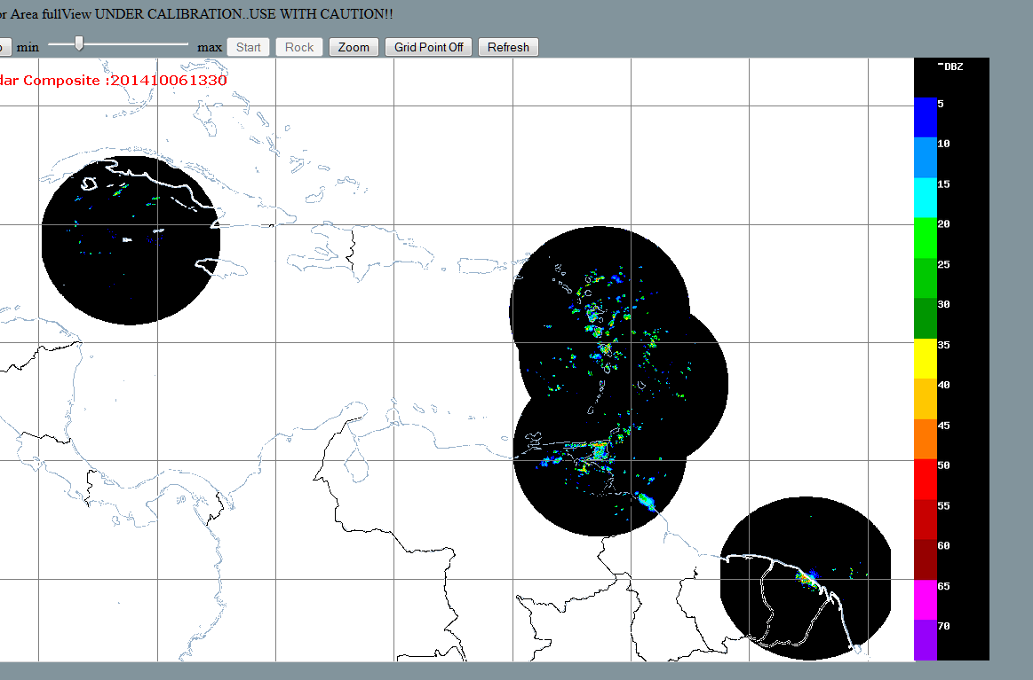

Figure 1: The full Caribbean mosaic from the website

of the Barbados Meteorological Service.

________

November 2014