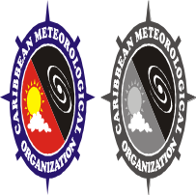
C A R I B B E A N
M E T E O R O L O G I C A L
O R G A N I Z A T I O N

CARIBBEAN METEOROLOGICAL COUNCIL Doc. 3(a)
FIFTY-FIFTH SESSION

Belize City, BELIZE, 12-13 NOVEMBER 2015

THE COORDINATING DIRECTOR’S REPORT - 2015

ON CMO HEADQUARTERS UNIT ACTIVITIES

(Submitted by the Coordinating Director)

1. This document highlights activities of the CMO Headquarters since the 54th session of the Council, held in Jamaica on 24-25 November 2014. Factors affecting operational aspects at the Headquarters and other matters of interest are also mentioned for information and guidance where appropriate. Details of some activities and developments, where necessary, will be dealt with under separate agenda items.

2. Since the last session of the Caribbean Meteorological Council in November 2014, the weather has been a feature in one form or another. In general, conditions around the Caribbean have been dry, with below normal rainfall through most of the Caribbean. In fact, the Caribbean Institute for Meteorology and Hydrology (CIMH) had issued a drought watch or drought warnings for most CMO Member States except Guyana, Trinidad and Northern Belize. The general deficit in rainfall, which started in the normal dry season in the first half of the year, continued into the normal wet/hurricane season as a moderate to strong El Niño developed during the second half of the year. The atmospheric conditions generally associated with a significant El Niño, along with cooler than normal sea surface temperatures in the North Atlantic Ocean, were not conducive to the formation of a large number of tropical storms and hurricanes.

3. In the Caribbean/Atlantic basins, the seasonal average is 12 named storms, including six hurricanes, of which three would be major hurricanes. In general, the Eastern and Central Atlantic Ocean were the only areas conducive to tropical cyclone development; but conditions rapidly became hostile to cyclones as they moved westward towards the Eastern Caribbean islands and Caribbean Sea. This is well depicted in the season summary map, prepared at the end of October 2015, shown as Figure 1 in ANNEX I. By the end of October 2015, there were 10 named storms, including just three hurricanes, comprising the unusual Hurricane Fred that struck the Cape Verde Islands off the coast of West Africa; Hurricane Danny that briefly became a major hurricane in the Central Atlantic before rapidly weakening; and major Hurricane Joaquin. Joaquin was one of the strongest storms on record to affect the Bahamas, causing significant damage and the loss at sea of a cargo container ship with 33 crew members. It also caused damage in the Turks and Caicos Islands, Eastern Cuba and Bermuda.

4. Notwithstanding a forecast for below-average seasonal activity, tropical cyclone forecasters always indicate that countries should remain well prepared because it only takes one depression, storm or hurricane making landfall to make it an active season for an affected place. This was the case in 2015 for the island of Dominica, particularly with the passage of Tropical Storm Erika.

5. Operational discussions and analyses from Meteorological Services showed that on 21 August 2015, a tropical wave moved off the West African coast into the eastern Atlantic Ocean, where conditions favoured development. Over the next few days, the system gradually strengthened, becoming Tropical Storm Erika as it reached about 1000 miles (1600 km) east of the Caribbean island chain. After that time however, Erika encountered very unfavourable and even hostile conditions. Neither the numerical weather prediction guidance nor observations suggested that tropical storm wind conditions could be maintained south of the centre, which was predicted to go through the Leeward Islands. As Erika approached the island chain, it was literally being torn apart in this environment, having a difficult time to maintain its structure. Notwithstanding that, conditions in the upper atmosphere still favoured heavy rainfall. Regrettably, this shrinking cloud mass slammed into the very mountainous island of Dominica, which then enhanced the predicted rainfall amounts. Figure 2 shows a satellite image the day before reaching the islands. Figure 3 shows a radar composite of Erika primarily affecting Dominica. Erika did not show the typical cyclonic storm structure, and no tropical storm winds occurred, but the very heavy rainfall for about 5 hours on the morning of 27 August produced 10 to 12 inches (250 to 305 millimetres) of rainfall, approximately 200% more than forecast, resulting in devastating floods, the reported loss of 14 lives and another 16 persons still missing, presumed dead. It inflicted approximately XCD 1.3 billion in damage that would likely set the island back economically for many years.
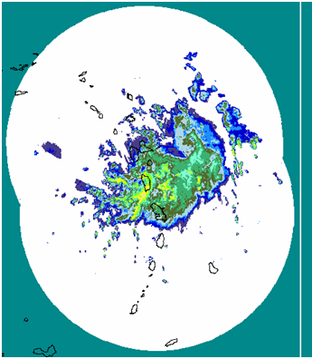
Figure 3: Radar composite – Tropical Storm Erika, 8:15AM Aug 27, 2015. Courtesy Météo-France
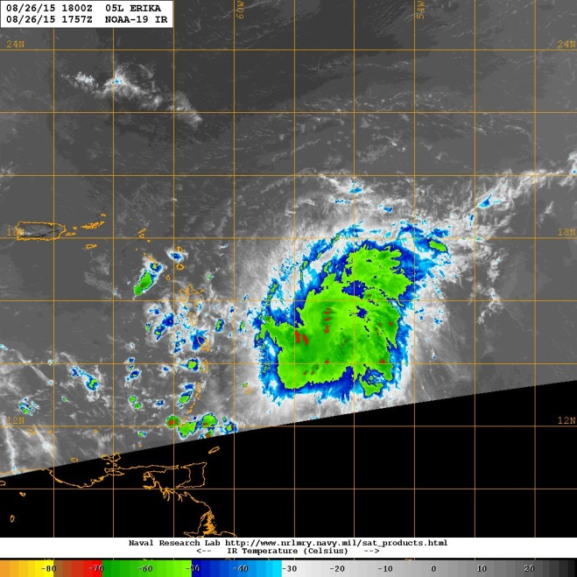
Figure 2: Satellite image of Tropical Storm Erika approaching the islands on Aug 26, with most of the clouds to the south of the estimated centre (red dot)
Courtesy NOAA/Naval Research Lab

6. Throughout the Hurricane season, the CMO Headquarters routinely monitors the effectiveness of the regional warning system, including the timeliness and content of the various warnings issued by the National Meteorological and Hydrometeorological Services (NMHS) in Member States, as well as the response by disaster management agencies. Before the start of the 2015 hurricane season, as a contribution to regional hurricane preparedness, the CMO Headquarters organized a visit to St. Kitts by one of the hurricane reconnaissance aircraft, known as a “Hurricane Hunter”, operated by the United States Air Force Reserves. This was part of the annual Caribbean Hurricane Awareness Tour (CHAT), carried out by the USAF and the US National Oceanic and Atmospheric Administration (NOAA). CMO is already organizing with the US authorities for a similar tour to Tortola in the British Virgin Islands before the start of the 2016 hurricane season.

7. Activities of the CMO Headquarters in 2015 were dominated by the preparation for, participation in and follow-up to the 17th World Meteorological Congress, held in Geneva, Switzerland in May-June 2015. The Congress is the supreme body of the World Meteorological Organization (WMO). The WMO Congress assembles delegates of its Member States and Territories every four years to set out the policies and programmes that impact on matters relating to weather, climate and water in every country of the world, whether large or small, developed or developing. Over the years, primarily because of cost, it has not been easy for several CMO Member States to actively participate routinely in WMO activities at the Congress level, focussing their attention primarily on the WMO regional activities. It has therefore always been imperative for the Caribbean Meteorological Organization, as one of the pillars of its mandate, to actively participate in WMO activities at the highest level in order to ensure that the interests of small developing states are accounted for and to guide and advise the CMO Member States in their own related activities. For this reason, the Coordinating Director, as a member of the WMO Executive Council since 1999, maintains a strong and experienced team of senior Advisors and Experts that have all individually become fully versed in WMO’s programmes and activities.

8. The outcomes of the Congress itself will be brought to the Council in detail under Agenda Item 5 in particular. However, it is useful to specially mention to the Council, a few issues that will impact CMO Member States almost immediately. First, the implementation of the Global Framework for Climate Services (GFCS) will require Members to participate in the implementation of a new WMO Policy for the International Exchange of Climate Data and Products to Support the Implementation of the GFCS. As a major regional contribution to the GFCS, it is anticipated that the CIMH will receive designation within 2016 as a WMO Regional Climate Centre (RCC). Secondly, regional activities as part of the WMO Integrated Global Observing System (WIGOS) need to be accelerated, since WIGOS moves into its Pre-operational Phase from 2016. The provision of the highest quality meteorological services for the safety of aviation operations continues as a priority for WMO and the International Civil Aviation Organization (ICAO). The requirement for Meteorological Services to demonstrate their compliance with ICAO mandates needs priority attention of the Governments in CMO Member States. Disaster Risk Reduction was, as always, a major issue at the Congress. Global activities in this regard formed the main focus of the Third United Nations World Conference on Disaster Risk Reduction (WCDRR), which took place in Japan in March 2015. The CMO Headquarters and the CIMH contributed to and participated in WCDRR, which produced a post-2015 framework for disaster risk reduction around the world. Some of the proposed regional initiatives to emanate from WCDRR and the WMO Congress will also be discussed in detail in Agenda Item 5.

9. The 54th session of the Council requested the CMO Headquarters to develop a regional strategic plan for the meteorological community that would be linked to the Caribbean Community Strategic Implementation Plan. A considerable amount of time was spent on this matter in 2015 by the CMO Headquarters. This is a long time-consuming process which is determined by the collective effort of all Caribbean Community institutions, including the CMO Headquarters and the CIMH, and led by the Caribbean Community Secretariat. It is expected that regional consultations in connection with this plan will take more than one year to be completed, so that the Headquarters activities in this regard will continue to be intense.

10. Cooperation among regional institutions with common interests continued to be among the activities of the Headquarters in 2015. Consultations have been ongoing with the General Council of Martinique on the progress within the Carib-Risk Cluster Project, established in 2011 by the General Council of Martinique and co-financed by the European Union. Strengthening the collaboration between the Meteorological Service of France (Météo-France), the institutions of the CMO and the Meteorological Services of CMO Member States has been the subject of discussions in 2015. A draft of the proposed Working Arrangements between Météo-France and CMO will be presented to the Council for its consideration.

11. The CMO Headquarters continued in 2015, activities started in 2014 to provide technical advice to St. Vincent and the Grenadines in relation to flight operations and future meteorological services at the new international airport, which is nearing completion at Argyle on the southeast coast of St. Vincent. This activity is expected to continue even after the commissioning of the Airport.

12. Council will be pleased to note that, in the latter part of 2015, the level of financial contributions from Member States was a comparable to 2014. However, there were still six Member States that failed to meet their obligations. Details will be discussed under Agenda item 6(c).

13. ANNEX II to this document indicates meetings and other events attended (or scheduled attendance) by officers of the CMO Headquarters in 2015. This schedule of activities undertaken by the CMO Headquarters to date was quite heavy, particularly in a year that includes a Congress of the WMO, because all programs at regional and international levels had to be presented to the Congress in May-June 2015. Follow-up activities from the WMO Congress began immediately after and continued to the end of 2015, especially those related to new activities scheduled to commence in 2016. Although the financial situation did not permit all activities to be easily undertaken, the CMO Headquarters routinely has been able to “piggy-back” on events organized by others to carry out some CMO activities.

14. The CMO Headquarters continues to promote the participation in as many scientific, technical and training events as possible by the National Meteorological and Hydrometeorological Services and the CIMH, particularly those sponsored by the WMO and its partners that have a special relevance to the region. Most of the relevant international activities in 2015 were focussed on WMO activities, particularly the WMO Technical Commissions. The list below shows the events that the Coordinating Director was able to facilitate in 2015.
- WMO TCP/MMOP Workshop on Storm Surges and Wave forecasting, Miami, Florida, USA, January 20-23 [H. Whyte, Grenada]
- WMO Region Association IV GFCS Implementation Task Team Workshop, San José, Costa Rica, February 5-6 [A. Trotman & C. Van Meerbeeck, CIMH]
- WMO RA IV Working Group on Hydrology (First Meeting), February 23, and the Workshop on Hydrological Networks and Data, February 24-26), San Salvador, El Salvador [D. Farrell & S. Boyce, CIMH]
- WMO Training Workshop for National Meteorological and Hydrological Services (NMHSs) on “Designing Socio-Economic Benefits Studies of Meteorological/Hydrological Services and Products in the Caribbean", St. John’s, Antigua & Barbuda, February 23-27 [H. Whyte, Grenada & E. Burke, St. Kitts/Nevis]
- WMO RA IV Workshop on Hurricane Forecasting and Warning and Public Weather Services, Miami, Florida, USA, March 9-20 [J. Robertson, Grenada]
- Workshop for Directors of WMO Regional Training Centres, DWD Training Centre, Langen, Germany, March 16-20 [K.A. Caesar for D. Farrell]
- WMO CAgM Meeting of the Open Panel of CCl Experts (OPACE 4) on User Interface for Climate Adaptation and Risk Management, Guayaquil, Ecuador, March 23-25 [A. Trotman - member]
- WMO Workshop on Addressing Tropical Cyclone Forecasting Competencies within RA IV [K. Powery, Cayman Isl], San José, Costa Rica, April 9-10, in conjunction with the 37th Hurricane Committee (see HC-37)
- CCl/CBS Joint Expert Team on Regional Climate Centres (ET-RCCs) and the CCl Task Team on Regional Climate Outlook Forums (TT-RCOFs), Melbourne, Australia, September 21-23 [C. Van Meerbeeck, CIMH, BCT member on ET-RCCs]
- WMO Workshop on Advanced Functionalities of MCH for Trainers, Mexico City, Mexico, September 21-25 [S. Boyce, CIMH]
- WMO First Training Workshop on Seasonal Forecasting MedCOF participants, Madrid, Spain, October 26-30 [G. Niles & C. Forde, CIMH]
- WMO CAgM Expert Team of Agromet Products, Pune, India, November 6-7 [A. Trotman, CIMH, BCT ET member]

- - - - - - - - - - - - - - - - - - - - - - - - - - - - - - - - - - - - - - - - - - - - - - - - - - - - - - - - - - - - -- - - - - - - - -
- WMO Joint Meeting of the CAeM Expert Team on Education, Training and Competency (ET-ETC) and CAeM Expert Team on Governance (ET-GOV), Wellington, New Zealand, November 30-December 3 [K.A. Caesar, CIMH, BCT core member ET-ETC]
- WMO RA-IV Workshop on WIGOS, Willemstad, Curaçao, December 1-3 [K. Powry, Cayman Isl. BCT National WIGOS FP; H. Danny, Guyana National WIGOS FP, special CMO participant]
- First meeting of the CIMO Task Team on Operational Metrology (ET-OpMet-1), Ljubljana, Slovenia, December 1-4 [D. Prescod, CIMH - BCT TT member]
- - - - - - - - - - - - - - - - - - - - - - - - - - - - - - - - - - - - - - - - - - - - - - - - - - - - - - - - - - - - -- - - - - - - - -

15. The Council will recall that, at its 44th session, it acknowledged the retirement from the staff of the CMO Headquarters of its long-serving Administrative Officer after forty-four years on the job. This senior post is critical to the operations of the Headquarters and the Organization in general. The Coordinating Director is pleased to introduce her replacement, Mrs Natalie Araujo-O’Brien, to the renamed post of Finance and Administrative Officer. Mrs Araujo-O’Brien joined the Headquarters staff on June 1st 2015. She holds a Bachelor's degree in Management Studies and a Master's degree in Business Administration. She brings to the CMO Headquarters a wealth of experience in finance and administration from both the private and public sectors. It is anticipated that her varied background and experience will allow her to contribute significantly to the Organization’s finance and administration activities.


16. The CMO, as an Organization, comprises 16 Member States. The Directors/Heads of Meteorological and Hydrometeorological Services are the primary points of contacts for Member States with the organs of the CMO (Headquarters & CIMH). Their contribution to their Services and to meteorology and hydrology at the local, regional and international levels is critical. On this occasion, the CMO headquarters congratulates the Acting Chief Hydrometeorological Officer of Guyana, Garvin Cummins, on obtaining his Doctorate in April 2015 from the University of Genoa in Italy. Dr Cummings’s PhD thesis was titled "Towards building a reliable flood nowcasting procedure for small and very small river basins" in the Liguria Region of northwestern Italy.


Action Proposed to Council:

17. The Council is invited to:
- Note the activities and issues concerning the CMO Headquarters in 2015, particularly those dealing with the implementation of major WMO-related activities, and issues concerning the wider Caribbean Community;
- Discuss the impact of the 2015 hurricane season on the region and, in particular, the impact on the Commonwealth of Dominica;
- Note and commend staff changes at the CMO Headquarters and congratulate Dr. Garvin Cummins of Guyana on attaining his Doctorate in 2015;

_________

CMO Headquarters
October 2015

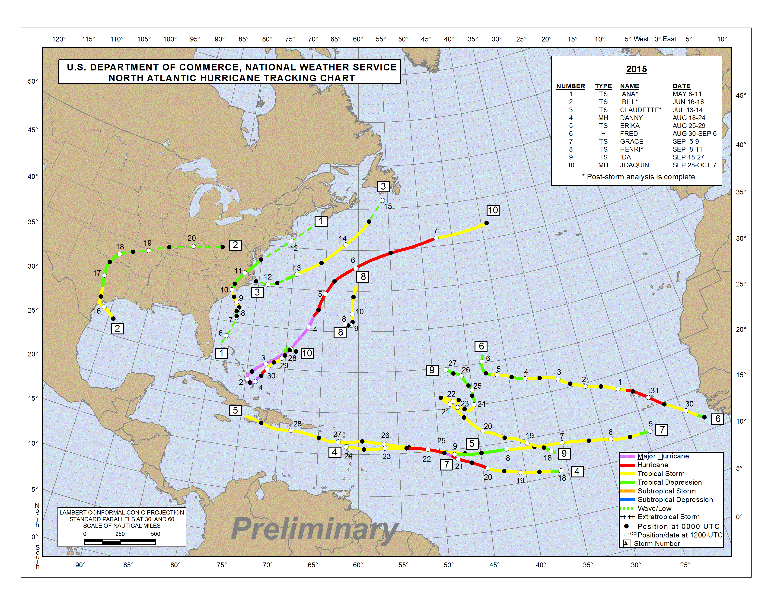
2015 SUMMARY TABLE (TO OCTOBER 27)
Name | Dates | Max Wind (mph)
TS ANA  TS BILL  TS CLAUDETTE  MH DANNY  TS ERIKA  H FRED  TS GRACE  TS HENRI  TD NINE  TS IDA  MH JOAQUIN | 8-11 MAY  16-20 JUNE  13-14 JULY  18-24 AUG  25-29 AUG  30 AUG-6 SEP  5-9 SEP  9-11 SEP  16-19 SEP  18-27 SEP  28 SEP-7 OCT | 60  60  50  115  50  85  50  40  35  50  115

Figure 1: 2015 Tropical Storms and Hurricane tracks (preliminary) in the Atlantic-Caribbean basin – End of October (courtesy NOAA/NHC)

2015 CMO HQ Missions

(Not related to the CMC meetings)

January 4-8 95th American Meteorological Society (AMS) Annual Meeting: “Fulfilling the Vision of Weather, Water, and Climate Information for Every Need, Time, and Place”, Phoenix Convention Center, Phoenix, Arizona, USA.
in conjunction with
January 8 NOAA/NWS International Session, Sheraton Phoenix Downtown [CD & STO]
January 28 Finland/ACS SHOCS II – 5th Project Board Meeting of SHOCS-II [teleconference – [CD]
February 17-20 WMO Inter-Commission Coordination Group on WIGOS (ICG-WIGOS), 4th Session, WMO Secretariat, Geneva [CD]
February 19 CIMH Second Programme Steering Committee for the Programme for Building Regional Climate Capacity in the Caribbean (BRCCC), Barbados [C. Layne, CMO Rep]
March 3-5 CARPHA Expert Consultation re Chikungunya in the Caribbean, Port of Spain [CMO Rep – W. Depradine CIMH]
March 14-18 The Third United Nations World Conference on Disaster Risk Reduction (WCDRR), Sendai City, Miyagi Prefecture, Japan, (five days inclusive)[CD & P/CIMH]
in conjunction with
WMO Symposium on MultiHazard Early Warning Systems and Services (side event of WCDRR-III), 16 March
in conjunction with
March 19-20 Official CMO visit to the Japan Meteorological Agency (March 19) and the Tokyo Climate Centre (March 20), Tokyo, Japan [CD & P/CIMH]
April 13-17 WMO RA IV Hurricane Committee, 37th session, San José, Costa Rica [CD, STO, J. Tibbetts & K. Powery, Cayman Isl.]
April 23-24 NOAA/USAF Caribbean Hurricane Awareness Tour (CHAT), St. Kitts [CD]
April 27-May 1 NOAA Satellite Conference, Greenbelt, VA, USA – [K-A Caesar - CIMH & STO]
May 23-24 WMO FINAC-34 [CD]
in conjunction with
May 25-June 12 Seventeenth WMO Congress (Cg-17), Geneva, Switzerland [CD, P/CIMH, STO & K-A Caesar, CIMH]
followed by
June 15-17 67th session of the WMO Executive Council, [CD]
June 15-19 Virtual Meetings of the Clusters on the Draft CARICOM Operational Plan [STO]
July 2-4 36th Regular Meeting, Conference of Heads of Government of the Caribbean Community, Barbados [CD]
July 8-9 Workshop/Seminar on Seismic, Tsunami and Volcanic Risk, Chilean International Cooperation Agency (AGCI), ACS Headquarters, Port of Spain [STO]
August 11-13 WMO Workshop on the WMO Information System (WIS) Metadata, Barbados [STO]
August 25-27 ICAO/WMO Seminar/Workshop on Aeronautical Meteorological Package/Quality Management System (AMP/QMS) and How it Relates to SIGMET Information for the NAM/CAR/SAM Regions, Costa Rica [STO as instructor]
September 14-18 WMO-CMO Executive Management Consultation, September 14; WMO Task Team meeting for the Plan for the WIGOS Pre-Operational Phase (TT-PWPP), September 15-17; and ICG-WIGOS Management Discussion, September 18, WMO Secretariat, Geneva [CD]
October 22- 23 CMO/Météo-France Consultative Meeting, Fort-de-France, Martinique [CD]
October 26-28 Intergovernmental Board on Climate Services (IBCS) Management Committee, 3rd Meeting, WMO, Geneva [David Farrell, P/CIMH]
October 28-29 CMO Mission to St. Vincent – Argyle Airport issues. [STO technical meetings with Aviation & Argyle officials]
- - - - - - - - - - - - - - - - - - - - - - - - - - - - - - - - - - - - - - - - - - - - - - - - - - - - - - - - - - - - -- - - - - - - - -
November 18 Finland/ACS – Final Project Board Meeting of SHOCS-II, Barbados
November 26-27 Caribbean Regional Climate Outlook Forum (2nd Dry Season CARICOF), Basseterre, St. Kitts [CD]
December 1-3 WMO RA-IV Workshop on WIGOS, Willemstad, Curaçao [STO as resource person]
- - - - - - - - - - - - - - - - - - - - - - - - - - - - - - - - - - - - - - - - - - - - - - - - - - - - - - - - - - - - -- - - - - - - - -

